PIZZA SALES QUERIES

# **A. Key Performance Indicators (KPIs)**

## 1. Total Revenue

SELECT SUM(total_price) AS Total_Revenue FROM pizza_sales;

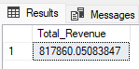

## 2. Average Order Value

SELECT SUM(total_price) / COUNT(DISTINCT order_id) AS Average_Order_Value   
FROM pizza_sales;

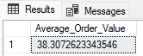

## 3. Total Pizza Sold

SELECT SUM(quantity) AS Total_Pizza_Sold   
FROM pizza_sales;

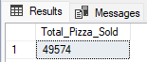

## 4. Total OrdersSELECT COUNT(DISTINCT order_id) AS Total_Orders FROM pizza_sales;

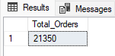

## 5. Average Pizzas Per OrderSELECT CAST(CAST(SUM(quantity) AS DECIMAL(10,2)) /

CAST(COUNT(DISTINCT order_id) AS DECIMAL(10,2)) AS DECIMAL(10,2)) AS Avg_Pizzas_Per_Order FROM pizza_sales;

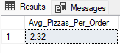

# **B. Daily Trends for Total Orders**

SELECT DATENAME(DW, order_date) AS order_day, COUNT(DISTINCT order_id) AS Total_orders

FROM pizza_sales

GROUP BY DATENAME(DW, order_date)

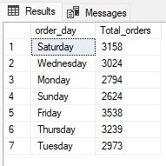

# **C. Monthly Trend for Orders**

SELECT DATENAME(MONTH, order_date) AS Month_Name , COUNT(DISTINCT order_id) AS Total_Orders

FROM pizza_sales

GROUP BY DATENAME(MONTH, order_date)

ORDER BY Total_Orders DESC

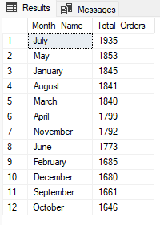

# **D. Percentage of Sales of Pizza Category**

SELECT pizza_category, SUM(total_price) AS Total_Sales,SUM(total_price) * 100 /(SELECT SUM(total_price) FROM pizza_sales) AS Total_Sales_Percentage

FROM pizza_sales

GROUP BY pizza_category

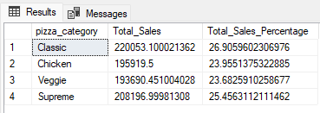

# **E. Percentage of Sales of Pizza Size**

SELECT pizza_size, SUM(total_price) AS Total_Sales,SUM(total_price) * 100/

(SELECT SUM(total_price) FROM pizza_sales) AS Total_Sales_Percentage

FROM pizza_sales

GROUP BY pizza_size

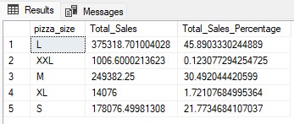

# **F. Total Pizzas Sold by Pizza Category**

SELECT pizza_category, SUM(quantity) AS Total_Quantity_Sold

FROM pizza_sales

GROUP BY pizza_category

ORDER BY Total_Quantity_Sold DESC

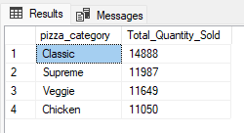

# **G. Top 5 Pizzas by Revenue**

SELECT TOP 5 pizza_name, SUM(total_price) AS Total_Revenue

FROM pizza_sales

GROUP BY pizza_name

ORDER BY Total_Revenue DESC

***Output***

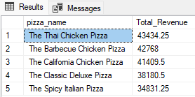

# **H. Bottom 5 Pizzas by Revenue**

SELECT TOP 5 pizza_name, SUM(total_price) AS Total_Revenue

FROM pizza_sales

GROUP BY pizza_name

ORDER BY Total_Revenue

***Output***

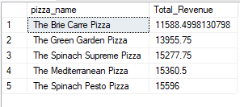

# **I. Top 5 Pizzas by Quantity**

SELECT TOP 5 pizza_name, SUM(quantity) AS Total_Pizza_Sold

FROM pizza_sales

GROUP BY pizza_name

ORDER BY Total_Pizza_Sold DESC

***Output***

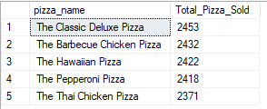

# **J. Bottom 5 Pizzas by Quantity**

SELECT TOP 5 pizza_name, SUM(quantity) AS Total_Pizza_Sold

FROM pizza_sales

GROUP BY pizza_name

ORDER BY Total_Pizza_Sold ASC

***Output***

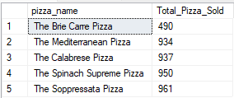

# **K. Top 5 Pizzas by Total Orders**

SELECT TOP 5 pizza_name, COUNT(DISTINCT order_id) AS Total_Orders

FROM pizza_sales

GROUP BY pizza_name

ORDER BY Total_Orders DESC

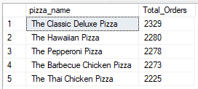

# **L. Bottom 5 Pizzas by Total Orders**

SELECT TOP 5 pizza_name, COUNT(DISTINCT order_id) AS Total_Orders

FROM pizza_sales

GROUP BY pizza_name

ORDER BY Total_Orders ASC

